**Dynamic features of running**

**Georgi Dimenchev - Medical University of Plovdiv - Bulgaia**

**It is well-known from sport’s literature that specific rhythm of movement, which involves quick foot strike from the supporting position and relatively long drive phase of running, is typical for ranking sprinters.**

**The time of foot strike of elite sprinters is**

**approximately 0.06-0.08 seconds.**

**Special research, in which around 2000 untrained kids and teenagers participate, denotes that when the participants give their personal best, the supporting reaction time varies from 150 to 160 ms, and the time of trained athletes varies from 110 to 130 ms.**

**In the same time there are exceptions (1;100) among children with a slow foot strike. Those children distinguish themselves from their peers by showing particular neuromuscular coordination and tension, which are specific for sprinting, and reach foot strike time that varies from 0.08 to 0.09 seconds.**

**Such kids, according to the most important criterium of correct and accurate running technique, acquire rhythm of movements closest to those of elite sprinters.**

|  |  |  |  |  |  |  |  |  |  |  |  |  |  |  |  |  |  |  |
| --- | --- | --- | --- | --- | --- | --- | --- | --- | --- | --- | --- | --- | --- | --- | --- | --- | --- | --- |
| ***AGE*** | **11** | | | **12** | | | **13** | | | **14** | | | **15** | | | **16** | | |
| ***LEVEL*** | **H** | **M** | **L** | **H** | **M** | **L** | **H** | **M** | **L** | **H** | **M** | **L** | **H** | **M** | **L** | **H** | **M** | **L** |
| ***DURATION OF THE GROUND REACTION FORSES - IN MESEC.*** | **131** | **146** | **151** | **125** | **136** | **145** | **122** | **137** | **143** | **103** | **112** | **128** | **95** | **104** | **109** | **90** | **98** | **100** |

***The table is the adapted for tennis players***

**It is possible that success in sports, which require high level of speed and power qualities, is premised on this exceptional asset those kids have in themselves;**

**QUICK AND ABRUPT CHANGE IN THE DIRECTION OF MOVEMENT.**

**THE DURATION OF SUPPORTING REACTION IS GENETICALLY PREDISPOSED AND IT IS NOT SUSCEPTIBLE TO TRAINING.**

**Its high level serves as an additional, highly informative and reliable factor in the selection of kids for sports that require speed and power.**

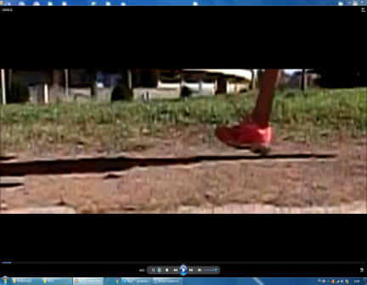 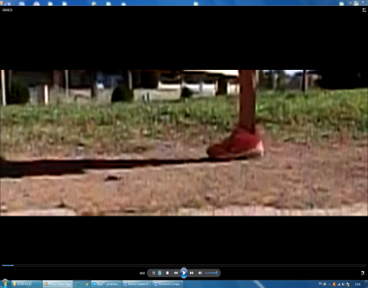 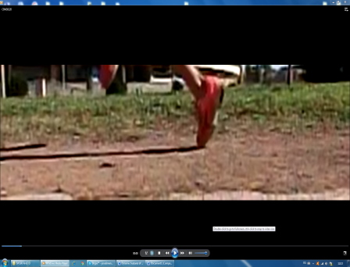

**1 2 3**

**Measuring devices :**

[**http://swiftperformance.com/products/speedmat/**](http://swiftperformance.com/products/speedmat/) **-> contact time**